实验7 结构与联合实验
一、实验目的
1．通过实验，熟悉和掌握结构的说明和引用、结构的指针、结构数组、以及函数中使用结构的方法。
2．通过实验，掌握动态储存分配函数的用法，掌握自引用结构，单向链表的创建、遍历、结点的增删、查找等操作。
3．了解字段结构和联合的用法。

二、实验题目及要求
1．表达式求值的程序验证题
设有说明：
char u[]="UVWXYZ";
char v[]="xyz";
struct T{
int x;
char c;
char *t;
}a[]={{11,ˊAˊ,u},{100, ˊBˊ,v}},*p=a;
请先自己计算下面表达式的值，然后通过编程计算来加以验证。(各表达式相互无关)
序号 | 表达式 | 计算值 | 验证值
1 | (++p)->x | 100 | 100
2 | p++,p->c | B | B
3 | *p++->t,*p->t | x | x
4 | *(++p)->t | x | x
5 | *++p->t | V | V
6 | ++*p->t | V | V

2．源程序修改替换题
给定一批整数，以0作为结束标志且不作为结点，将其建成一个先进先出的链表，先进先出链表的指头指针始终指向最先创建的结点（链头），先建结点指向后建结点，后建结点始终是尾结点。
- 源程序中存在什么样的错误（先观察执行结果）？对程序进行修改、调试，使之能够正确完成指定任务。
源程序如下：
#include "stdio.h"
#include "stdlib.h"
struct s_list{
int data; /* 数据域 */
struct s_list *next; /* 指针域 */
} ;
void create_list (struct s_list *headp,int *p);
// void create_list(struct s_list **headp, int*p);
void main(void)
{
struct s_list *head=NULL,*p;
int s[]={1,2,3,4,5,6,7,8,0}; /* 0为结束标记 */
create_list(head,s); /* 创建新链表 */
// create_list(&head, s);
p=head; /*遍历指针p指向链头 */
while(p){
printf("%d\t",p->data); /* 输出数据域的值 */
p=p->next; /*遍历指针p指向下一结点 */
}
printf("\n");
}
void create_list(struct s_list *headp,int *p)
// void create_list(struct s_list **headp,int *p)
{
struct s_list * loc_head=NULL,*tail;
if(p[0]==0) /* 相当于*p==0 */
;
else { /* loc_head指向动态分配的第一个结点 */
loc_head=(struct s_list *)malloc(sizeof(struct s_list));
loc_head->data=*p++; /* 对数据域赋值 */
tail=loc_head; /* tail指向第一个结点 */
while(*p){ /* tail所指结点的指针域指向动态创建的结点 */
tail->next=(struct s_list *)malloc(sizeof(struct s_list));
tail=tail->next; /* tail指向新创建的结点 */
tail->data=*p++; /* 向新创建的结点的数据域赋值 */
}
tail->next=NULL; /* 对指针域赋NULL值 */
}
headp=loc_head; /* 使头指针headp指向新创建的链表 */
// *headp = loc_head;
}

运行结果截图
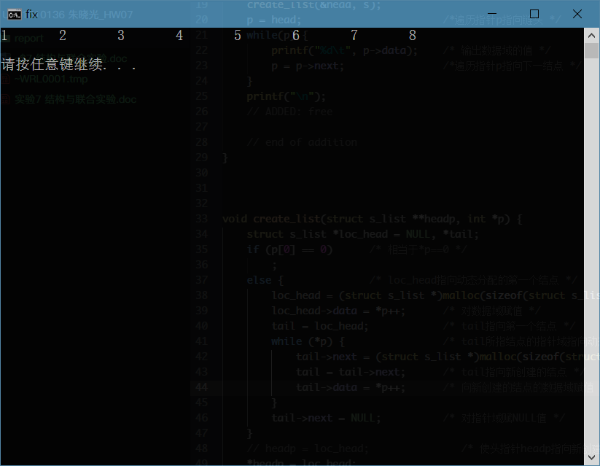

（2）修改替换create_list函数，将其建成一个后进先出的链表，后进先出链表的头指针始终指向最后创建的结点（链头），后建结点指向先建结点，先建结点始终是尾结点。
...
void create_list(struct s_list **tailp, int *data) {
struct s_list *prev;
if (data[0] == 0) { *tailp = NULL; return; }
else {
if ((*tailp = (struct s_list *)malloc(sizeof(struct s_list))) == NULL) { exit(-1); }
(*tailp)->data = data[0];
(*tailp)->next = NULL;
for (prev = *tailp, ++data; *data; ++data, prev = *tailp){
if (((*tailp) = (struct s_list *)malloc(sizeof(struct s_list))) == NULL) { exit(-1); }
(*tailp)->next = prev;
(*tailp)->data = *data;
}
return;
}
}
...
运行结果截图
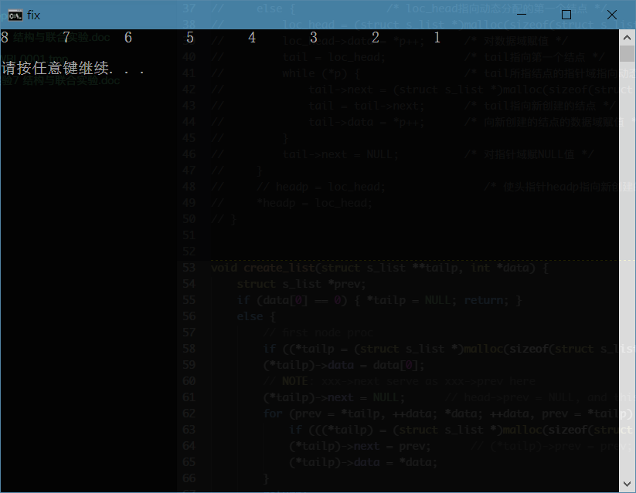

3．编程设计题
（1）设计一个字段结构struct bits，它将一个8位无符号字节从最低位向最高位声明为8个字段，各字段依次为bit0, bit1, …, bit7，且bit0的优先级最高。同时设计8个函数，第i个函数以biti(i=0,1,2,…,7)为参数，并且在函数体内输出biti的值。将8个函数的名字存入一个函数指针数组p_fun。如果bit0为1，调用p_fun[0]指向的函数。如果struct bits中有多位为1，则根据优先级从高到低依次调用函数指针数组p_fun中相应元素指向的函数。8个函数中的第0个函数可以设计为：
void f0(struct bits b)
{
Printf(“the function %d is called!\n”,b);
}
源程序清单
#include <stdio.h>
#include <stdlib.h>

///////////////////////////////////////////////////////////

struct ISR_BITS {
unsigned int bit0: 1;
unsigned int bit1: 1;
unsigned int bit2: 1;
unsigned int bit3: 1;
unsigned int bit4: 1;
unsigned int bit5: 1;
unsigned int bit6: 1;
unsigned int bit7: 1;
unsigned int rsv : 8;
};

union ISR_REG {
unsigned short all;
struct ISR_BITS bit;
};

void isr0(void) { puts("The Interrupt Service Routine isr0 is called!"); }
void isr1(void) { puts("The Interrupt Service Routine isr1 is called!"); }
void isr2(void) { puts("The Interrupt Service Routine isr2 is called!"); }
void isr3(void) { puts("The Interrupt Service Routine isr3 is called!"); }
void isr4(void) { puts("The Interrupt Service Routine isr4 is called!"); }
void isr5(void) { puts("The Interrupt Service Routine isr5 is called!"); }
void isr6(void) { puts("The Interrupt Service Routine isr6 is called!"); }
void isr7(void) { puts("The Interrupt Service Routine isr7 is called!"); }

/////////////////////////////////////////////////////////////

void main(void) {

void (*p_isr[8])(void);
p_isr[0] = isr0; p_isr[1] = isr1; p_isr[2] = isr2; p_isr[3] = isr3;
p_isr[4] = isr4; p_isr[5] = isr5; p_isr[6] = isr6; p_isr[7] = isr7;

unsigned n, i;
scanf("%u", &n); getchar();

union ISR_REG *flags = (union ISR_REG *)malloc(n * sizeof(union ISR_REG));

for (i = 0; i < n; ++i) {
scanf("%hu", &(flags[i].all)); getchar();
}

for (i = 0; i < n; ++i) {

/**** CORE CODE ****/

printf("%hu:\n", flags[i].all);

if (flags[i].bit.bit0) { p_isr[0](); }
if (flags[i].bit.bit1) { p_isr[1](); }
if (flags[i].bit.bit2) { p_isr[2](); }
if (flags[i].bit.bit3) { p_isr[3](); }
if (flags[i].bit.bit4) { p_isr[4](); }
if (flags[i].bit.bit5) { p_isr[5](); }
if (flags[i].bit.bit6) { p_isr[6](); }
if (flags[i].bit.bit7) { p_isr[7](); }

putchar('\n');

/**** END ****/

}

for (i = 0; i < n; ++i) {
free(flags+i);
}

return;
}
运行结果截图
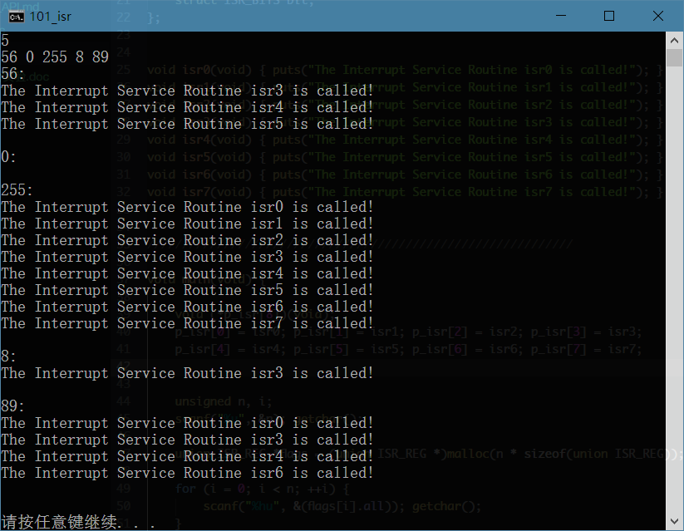

（2）用单向链表建立一张班级成绩单，包括每个学生的学号、姓名、英语、高等数学、普通物理、C语言程序设计四门课程的成绩。用函数编程实现下列功能：
(1) 输入每个学生的各项信息。
(2) 输出每个学生的各项信息。
(3) 修改指定学生的指定数据项的内容。
(4) 统计每个同学的平均成绩（保留2位小数）。
(5) 输出各位同学的学号、姓名、四门课程的总成绩和平均成绩。
源程序清单
#include <stdio.h>
#include <stdlib.h>
#include <string.h>

#define True 1

//////////////////////////////////

enum Courses {
English = 0,
Math,
Physics,
C
};

int getCourseCode(char const *name) {
if (!strcmp(name, "English")) { return 0; }
else if (!strcmp(name, "Math")) { return 1; }
else if (!strcmp(name, "Physics")) { return 2; }
else if (!strcmp(name, "C")) { return 3; }
else { return -1; }
}

#define COURSE_CNT 4

//////////////////////////////////

/**** Student Class ****/

typedef struct _Student {
char id[15];
char name[20];
float grades[COURSE_CNT];
double avg;
} Student;

Student * _initStudent(void) {
/* create a Student record
RETURN the pointer of the record
*/
Student *stu = (Student *)malloc(sizeof(Student));
scanf("%s", stu->id); getchar();
scanf("%s", stu->name); getchar();
for (int i = 0; i < COURSE_CNT; ++i) {
scanf("%f", &(stu->grades[i])); getchar();
}
return stu;
}

void _printStudent(Student stu) {
/* print out a formated Student record
NO RETURN
*/
printf("%-15s%-20s%-10.2f%-10.2f%-10.2f%-10.2f\n",
stu.id, stu.name,
stu.grades[English],
stu.grades[Math],
stu.grades[Physics],
stu.grades[C]);
return;
}

void _printStudentStat(Student *stu) {
/* ID NAME SUM AVG
*/
double sum = 0;
for (int i = 0; i < COURSE_CNT; ++i) {
sum += stu->grades[i];
}
stu->avg = sum / COURSE_CNT;
printf("%-15s%-20s%-10.2f%-10.2f\n",
stu->id, stu->name,
sum, (sum / COURSE_CNT));
return;
}

double _compareStudent(Student Alice, Student Bob) {
return (Alice.avg - Bob.avg);
}

void _modifyStudent(Student *stu,
char const *course_name,
float new_score) {
stu->grades[getCourseCode(course_name)] = new_score;
return;
}

void _freeStudent(Student *stu) {
free(stu);
}

//////////////////////////////////////////////////

/**** Node Class ****/
// index of Student records

typedef struct _Node {
Student *data;
struct _Node *next;
} Node;

Node * initStudents(int cnt) {
/* create $cnt Student records wrapped by Node
RETURN pointer of the chain's head
*/
Node *head = (Node *)malloc(sizeof(Node));
// init first Student
head->data = _initStudent();
head->next = NULL;
--cnt;
// init following Students
for (Node *subs = head; cnt; --cnt) {
subs->next = (Node *)malloc(sizeof(Node)); // create next Node
subs = subs->next; // move to next Node
subs->next = NULL;
subs->data = _initStudent(); // toggle data input
}
return head;
}

void printStudents(Node *cur) {
/* print out all Student records
*/
printf("%-15s%-20s%-10s%-10s%-10s%-10s\n",
"ID", "Name", "English", "Math", "Physics", "C");
for (; cur; cur = cur->next) {
_printStudent(*(cur->data));
// if (cur->next == NULL) { break; }
}
putchar('\n');
}

void printStudentsStat(Node *head) {
printf("%-15s%-20s%-10s%-10s\n",
"ID", "Name", "SUM", "AVG");
for (; head; head = head->next) {
_printStudentStat(head->data);
}
putchar('\n');
return;
}

void printStudentsAvg(Node *head) {
printf("%-15s%-20s%-10s\n",
"ID", "Name", "AVG");
for (; head; head = head->next) {
printf("%-15s%-20s%-10.2f\n",
head->data->id,
head->data->name,
head->data->avg);
// pass
}
putchar('\n');
return;
}

Node * getNodeById(Node *head, char const *id) {
Node *n = head;
for (; n; n = n->next) {
if (!strcmp(id, n->data->id)) { break; } // node found
if (n->next == NULL) { n = NULL; break; } // end of chain
}
return n;
}

void modifyChain(Node *head) {
/* given the head of the chain
will toggle input action
*/
char id[15]; char course_name[20]; float new_score;
scanf("%s %s %f", id, course_name, &new_score); getchar();
_modifyStudent(getNodeById(head, id)->data,
course_name,
new_score);
return;
}

double compareNode(Node A, Node B) {
return _compareStudent(*(A.data), *(B.data));
}

void sortChainSwapData(Node *prev, int len) {
int i, j;
Node *head = prev;
Node *subs;
for (i = 0; i < len-1; ++i, prev = prev->next) {
for (j = 0, subs = head; j < len-i-1; ++j, subs = subs->next) {
if (compareNode(*subs, *(subs->next)) > 0) {
Student *tmp = subs->data; // ye only have to swap the data pointer
subs->data = subs->next->data;
subs->next->data = tmp;
// puts("===================");
// printStudentsAvg(head);
// puts("===================");
}
}
}
return;
}

// HACK: got this piece completely from the book, need to study on it
void sortChainChangeRoute(Node **headp) {
Node *prev1, *p1, *prev2, *p2, *tmp; // notice the sequence here
// deal with headp - pointer to head pointer
p1 = *headp;
p2 = p1->next; prev2 = p1; // p2 is the current num
for (; p2; prev2 = p2, p2 = p2->next) {
if (compareNode(*p1, *p2) > 0) { // swap spaces p1 & p2 are pointing to
prev2->next = p1;
tmp = p1->next;
p1->next = p2->next;
*headp = p2; // update head pointer
p2->next = tmp;
p1 = p2;
}
}
// finished with headp
prev1 = *headp; p1 = prev1->next;
for (; p1->next; prev1 = p1, p1 = p1->next) {
p2 = p1->next; prev2 = p1; // p2 is the current num
for (; p2; prev2 = p2, p2 = p2->next) {
if (compareNode(*p1, *p2) > 0) {
tmp = p2->next;
prev1->next = p2;
prev2->next = p1;
p2->next = p1->next;
p1->next = tmp;
p1 = p2;
}
}
}
}

void freeStudents(Node *cur) {
Node *pnode;
while (cur) {
pnode = cur;
cur = cur->next;
_freeStudent(pnode->data); // free data storage
free(pnode); // free Node
}
return;
}

///////////////////////////////////////////////////////////////////////

void main(void) {

int cnt;
scanf("%d", &cnt); getchar();

Node *chain = initStudents(cnt);

printStudents(chain);

int change_cnt;
scanf("%d", &change_cnt); getchar();

for (; change_cnt; --change_cnt) {
modifyChain(chain);
}

puts("Alter:");
printStudents(chain);

puts("SumAndAvg:");
printStudentsStat(chain);

puts("Sort:");
// sortChainSwapData(chain, cnt);
sortChainChangeRoute(&chain);
printStudentsAvg(chain);

freeStudents(chain);

return;
}
运行结果截图
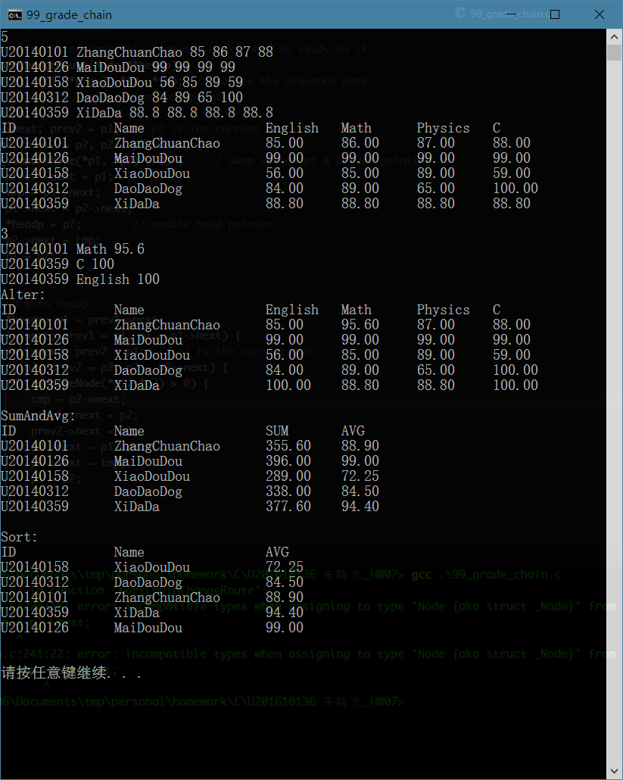

4．选做题
（1）对编程设计题第（2）题的程序，增加按照平均成绩进行升序排序的函数，写出用交换结点数据域的方法升序排序的函数，排序可用选择法或冒泡法。
（源程序清单中sortChainSwapData(...)函数）
（2）对选做题第（1）题，进一步写出用交换结点指针域的方法升序排序的函数。
（源原题程序清单中sortChainChangeRoute(...)函数）
（3）采用双向链表重做编程设计题第（2）题。
NULL

三、实验小结
通过这次实验，我更加深入地理解了函数编程与面向对象编程之间在程序设计哲学层面上的差别；同时也以肌肉记忆的方式，将malloc与free联系起来，养成内存管理的意识。

